Title Page
Project Title
Student Name: | Student ID: | Supervisor Name:
Povilas Kubilius | C16370803 | Leo Tilson
Link to Software Repository:

Table of contents

1) Project Statement
What is the purpose of your project? This should be about half a page.
To create a program which can predict the success of a new movie based on genre, the track record of the actors, budget, and other relevant factors. This should be useful to help production studios decide on the risks and rewards when planning a new movie, for Cinema management and TV stations deciding on rights to show a new movie, and also for research purposes.

2) Research
Several papers are available which describe projects similar to yours. What are the strengths and weakness of the various techniques used? e.g. https://www.researchgate.net/publication/332396741_Movie_Success_Prediction_using_Data_Mining_For_Data_Mining_and_Business_IntelligenceITA5007_of_Master_of_Computer_Application_School_Of_Information_Technology_and_Engineering?
Alternative Solutions
How does your project differ from say:
https://github.com/rian-van-den-ander/explorations/blob/master/film_success/film_rating_with_cast_best_regressor.py?

Technologies Researched
You will be using a database (Maria?) a language, a web server, Javascript and a ML library.
Why have you chosen these particular items. Some are obvious - you have to use javaScript, - and these require little discussion, but you should describe your chosen ML library in fairly good detail, and the reason that you have chosen it. https://hackernoon.com/top-8-python-libraries-for-machine-learning-and-artificial-intelligence-y08id3031

3) Approach and Methodology
What methodology are you using to ensure that your project will be well planned and executed? This is where you discuss your approach to the problem, and justify it. Much of this section is based on your class notes.
Test driven
Agile
Waterfall
Scrum
Kanban

4) Design
In section 2 you have listed all the technologies that you plan to use. How are they all going to be connected together? You will need some explanation of the way that data flows through the system, and how different layers interconnect.
Data are scraped from various websites, cleaned up, stored in a database. The database is used to produce a ML model. The user enters data about a movie in the website and this data is put through the model to try and predict the success of the movie.

Use Case Diagram
When the project is complete, how does a user use it? What kind of data do they have to supply? How do they supply it? What format is the data going to be in? Do they have to interact with the program, or is it completely automatic?
You will be using ML to create a model which will do all the heavy lifting. Is this model just created once, or does it update regularly? If I enter the list of actors, does it only work with actors already in the database, or is there some web-scraping done if it doesn’t recognise a name?

Planned GUI Design
You will be writing a web based GUI. Can we have a screenshot of what the web page is supposed to look like?

5) Prototyping and Development
How is the development going so far?
How far along are you?
What parts of the project have been implemented so far?
What problems have you encountered?
What changes have you been required to make based on changes in specifications, unexpected problems etc.?

6) Testing
Explain your planned testing approach: For example: who will be involved, what
test scripts are planned, how will the testing be executed.
a) Check that the program actually produces some useful output.
It be able to predict with some accuracy the success of a movie. Mainly you will be doing this by just using 90% of your data as training data, and 10% as test data.
b) Check that the code is bug-free, and that it doesn’t crash unexpectedly.

7) Issues and Risks
Your program may not work. This may be for a number of reasons, such as: libraries that you depend on may be buggy or may not work on a particular platform; the idea that you have may be unviable; the program may run correctly, but may be unusably slow.
What problems can you foresee arising, and what steps can you take to recover from these problems?
Your methods can only predict success based on certain factors. It cannot take into account political or social circumstances. For instance, we may find that impeachment movies are suddenly successful, no matter who is acting in them, but anything starring Kevin Spacey may be a complete failure.

8) Plan and Future Work

How are you going to arrange your time in order to achieve your goal?
You may want to create some timetable/ Gantt chart to help organise things.
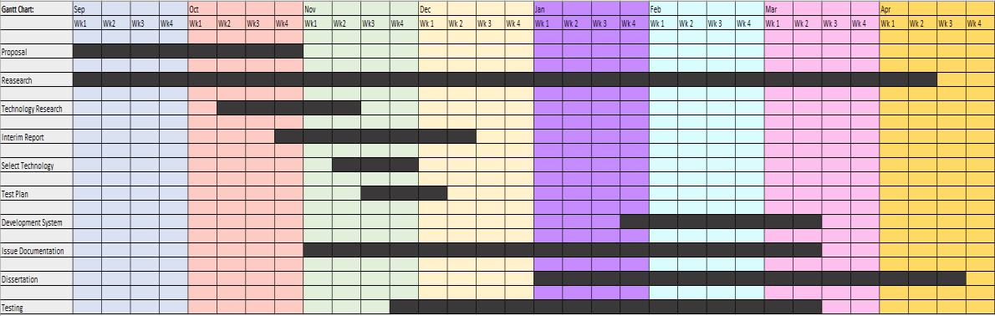

9) Bibliography
List all the books and journals that you have consulted, and also links websites that contain relevant information.

